|  |
| --- |
| **NUCL 355 Experiment 7** |
| Drag Force on Sphere  Professor M. Bertandano |
|  |
| School of Nuclear Engineering  Purdue University  Report of the Experiment By:  Weston Cundiff, Stephen Cox, Kara Luitjohan, Patrick Burk, Dominic Ghering, Michael Stryker, Austin Curtis, Matt Metzger, et. Al. |
| **Written By Alex Hagen** |
| **3/8/2011** |
|  |

# Introduction and Theory

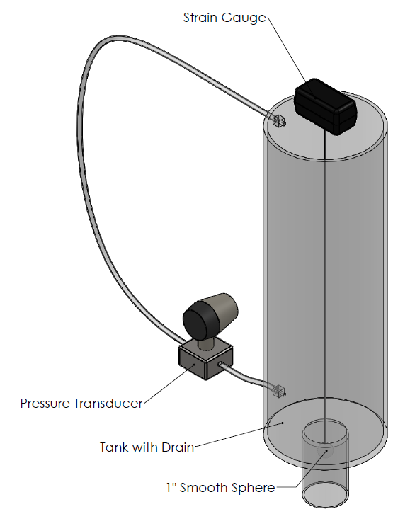An involved setup must be used to be able to gather data which can correlate the force of drag around a sphere and the Reynold’s Number, but it doesn’t need to be extremely complicated. The setup used in this experiment is very straightforward, with a smooth sphere suspended within a pipe, a large tank attached above that tank, and a pressure transducer to measure the change in pressure over time. The tank is filled with water and then quickly drained, to generate a high velocity flow past the sphere in the drain pipe. The pressure transducer takes data throughout the entire drain interval. This setup gives accurate data which can be used to relate the Reynold’s Number to the force of drag.

Figure . Experimental Setup (Drawn by A. Hagen)

Drag results from flow past an obstruction. Not only is flow stopped when it comes into direct contact with the obstruction, but the obstruction can cause even more flow stoppage through two phenomena. These are called pressure drag and form drag. Form drag occurs when the flow moves across a parallel body, which will provide friction into the flow. Pressure drag occurs when a stagnation point occurs on the bluff body, which will stop a certain percentage of the flow because of the difference in pressure made by the stagnation. For form drag, the force of drag is given by:

$$F_{D}=\int_{plate surface}{τ_{w}dA}$$

Whereas for pressure drag, the force of drag is given by:

$$F_{d}=\int_{body surface}{p dA}$$

Because this experiment uses a sphere, both types of drag will be present upon the surface, and so a different way of summing the forces must be used. In the pipe, the amount of force that pushes downward on the ball will not be being used for moving the flow. Through conservation of momentum, this demonstrates that the force downward on the ball will be exactly equal to the amount of force not used for flow, or the drag force. This can be measured by the strain gauge.

Once the force on the sphere is found, and the flow parameters are known (such as velocity and volumetric flow rate), the coefficient of drag can be found. This can be found using the equation:

$$F_{D}=C_{D}\left(\frac{1}{2}ρV_{p}^{2}\right)A$$

Generally the coefficient of drag is charted against the Reynold’s number, and the relationship between these two values is given below. The coefficient of drag quickly decays until leveling out through several orders of magnitude of Reynold’s Number. The “notch” towards 1000000 for the Reynold’s Number occurs due to separation of flow, a counterintuitive phenomenon.

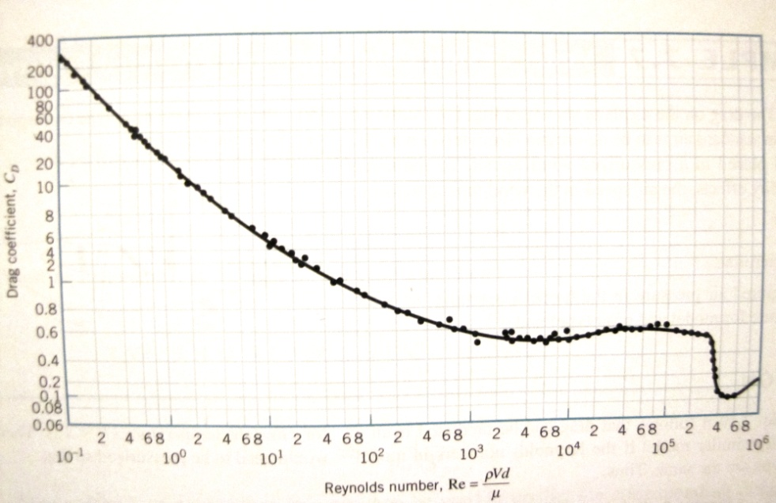

Figure .2 Drag Coefficient vs. Reynold's Number (Accepted Values from )

# Analysis and Discussion of Data

In analysis of data for this lab, several steps are required in data transformation before the actual data is obtained. It is easiest to explain these transformation steps in a visual fashion. First, because the pressure transducer is a familiar instrument for the laboratory group, the voltage reading from this instrument is converted to pressures and charted against time. This chart is shown below. The shape of it leads one to conclude that the pressure is increasing to a constant value over time, but because of the experimental setup, the physical meaning of this chart is that the pressure of water in the tank is decreasing from the full tank amount to a constant value over time. Because the pressure in the tank is directly proportional to the height of the water column, it is possible to find the velocity of fluid by finding the change over time of the pressure. To do this, the linear region of the chart below was fed into regression software to come up with the slope of that line, which was then the velocity of the system. A more mathematical description is given in the sample calculations.

Figure .1 Pressure vs. Time

A less straightforward transformation must be done to the data gathered by the strain gauge. This is an unfamiliar instrument for the lab group, and thus is not as easily transformed. Before the experiment was begun, the strain gauge was given for two different criteria: when no load was put on it, and when the weight of the sphere was placed on it. These two points allowed a best fit line equation to be solved for, and thus the Force upon the strain gauge to be solved for each point. This was plotted against time.

The chart below, of this measured force versus time, is still difficult to decipher. It shows the force on the strain gauge as increasing quickly to a maximum before decaying back down to a value close to zero. What value should be used when calculating the coefficient of drag? The answer to this question comes when understanding the physical and mathematical implications of the pressure chart above. The velocity that will be taken was the slope of the linear part of the chart, but it is also the highest possible slope on the chart. With the highest velocity of water pushing downward, there will be a highest downward force on the sphere. Thus, for the calculation of the coefficient of drag, the highest velocity from above must be matched with the highest force from the chart below. This is simple the peak of each of these charts.

Figure .2 Strain vs. Time

From the values of force as well as the values for velocity, the Reynold’s number can be calculated as can the drag coefficient. These are two values typically correlated, and so the values calculated in the experiment were plotted on an accepted chart for Reynold’s Number versus Drag Coefficient, as shown below. This chart has a shape consisting of a steadily decreasing drag coefficient that levels out, before a dip occurs. This dip occurs because of the separation of flow, which causes counterintuitive properties and smaller drags coefficients. The data calculated ends up fitting right around this dip, and is typically a very good fit, as shown in the figure below. A table in the reduced data shows that the error between the calculated and accepted value is at most 6%, generally much below that.

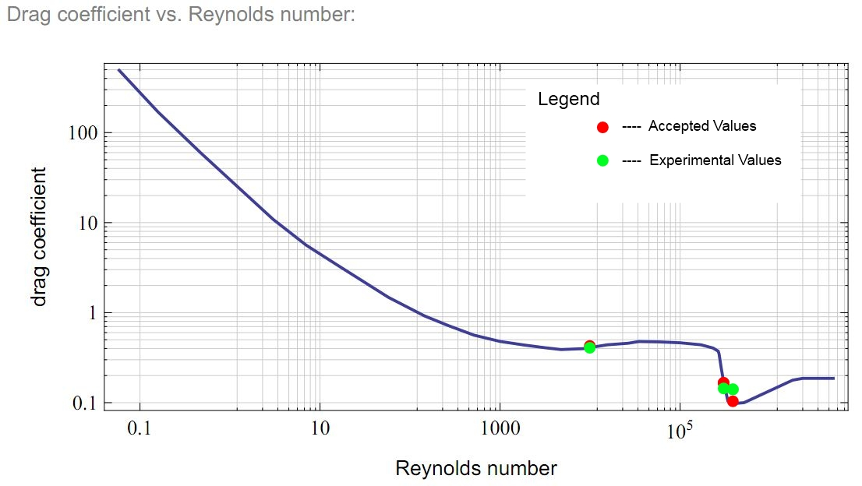

Figure .3 Drag Coefficient vs. Reynold's Number (Adapted from )

## Error

There is some inherent error within this experiment, most notable through the calculation of Reynold’s Number and the drag coefficient. With a sphere placed in the middle of a pipe, the flow through this pipe can no longer be simply modeled as straight flow through a circular pipe. For the analysis of this lab, it was, with the difference in area between the pipe opening and the sphere cross section used several times, and finally the differences in diameter used in the calculation of Reynold’s Number. Other error that may be present in this experiment are the fact that some data points were outliers (and likely every maximum force used), as well as the fact that the sphere was not fixed laterally.

## Recommendations

Although this lab was executed smoothly, there are certain places where it could have been more accurate. Two major recommendations to make this lab more accurate involve the lateral movement of the sphere and the opening of the valve. The valve was hand opened to a certain spot by eye, and thus there is error in this process because there is non-negligible opening time of the valve as well as error as to the point which it was opened. If possible, an instantaneous open valve should be used. The sphere was also able to move laterally, and thus the strain gauge was not completely accurate. If rollers could be used to center the sphere without causing too much longitudinal friction, that would be ideal.

# Conclusions

Drag force upon a sphere has been studied for many years, in a phenomenological way, using experimental data to understand its relationship to flow parameters. Through many experiments, an advanced curve has been developed when relating the drag coefficient to the Reynold’s Number. This curve explains that there is a strong and fully developed correlation between the flows inertial conditions and the amount of drag that occurs when the flow moved past the sphere.

This experiment, through three different flow rate experiments, allowed for the addition of three data points to the chart. These were found by using a gravity draining tank, with a small opening for the drain that allowed for very high Reynold’s Numbers to be achieved. A strain gauge took the force applied to the sphere to show the force of drag. The table below shows the new flow parameters as well as how the match up to accepted values.

|  |  |  |  |  |  |  |
| --- | --- | --- | --- | --- | --- | --- |
| Flow | Tank Flow Rate (Q_t) [m^3/s] | Reynold's Number (Re) [ ] | Drag Coefficient (C_d) [ ] | Max Strain (F) [N] | Accepted Drag Coefficient (C_da) [ ] | % Error |
| Full Open | 0.033 | 433660.37 | 0.10 | 1.67 | 0.11 | 5.64% |
| 5/6 Open | 0.031 | 409106.03 | 0.10 | 1.48 | 0.10 | 3.23% |
| 2/3 Open | 0.023 | 311716.93 | 0.15 | 1.25 | 0.15 | 0.81% |

Figure .1 Flow Data

It is notable to present that all three of the data points occurred in the “dip” of the chart caused by separation in the flow. The data held up to accepted values by following this somewhat complex phenomena, where the coefficient is held steady before suddenly dipping and recovering. The values of 5.64% and below error show that through the experiment, it was possible to get rather accurate data, even for complex sections of the graph.

Error is still present, even though the data seems to present a close fit to accepted values. The geometry of the setup was not perfectly analytically solved for. Because the geometric conditions are used in several steps in the data analysis, the propagation of this error could be important and large. Also, major losses, and the minor losses due to contraction were ignored. The contraction was quite significant, meaning the minor losses could be large. Also, the torus through which flow was possible around the sphere was quite small, and with the high velocities in this section of tubing, the boundary layer could have been quite large. In a future analysis, the minor and major losses should be included, as well as analytical solutions for the geometric conditions in the contraction of the tube and the passing of the sphere.

Overall, the experiment gave a physical, mathematical, and accurate description of the relationship that the drag coefficient around a sphere has with Reynold’s Number. It can be confidently said that the data presented gives a comprehensive picture of this phenomenon.

# Works Cited

Munson, Y. O. (2009). *Fundamentals of Fluid Mechanics.* Hoboken, NJ: Wiley and Sons, Inc.

Revankar, S. (2011). *Experiment #5: Turbulence and Vortex Visualization in Vertical Channel.* West Lafayette, IN: Purdue University School of Nuclear Engineering.

# Appendices

## Original Data

Original Data may be requested, but because of the sheer volume of data points, it is unrealistic to provide them in this report.

|  |  |  |  |  |  |  |  |  |
| --- | --- | --- | --- | --- | --- | --- | --- | --- |
| 1/10 second data | |  |  | 1/10 second data |  |  | 1/10 second data |  |
| Time | STRAIN GAGE CASE 1: Full Open | DP CELL CASE 1: Full Open | Time | STRAIN GAGE CASE2: 5/6 Open | DP CELL CASE2: 5/6 Open | Time | STRAIN GAGE CASE3: 2/3 Open | DP CELL CASE 3: 2/3 Open |
| 0.1 | 0.000305 | 0.109985 | 0.1 | 0.000763 | 0.109894 | 0.1 | 0.000153 | 0.112213 |
| 0.20 | 0.003967 | 0.110168 | 0.20 | 0.001221 | 0.110779 | 0.20 | 0.001526 | 0.112762 |
| 0.30 | -0.00061 | 0.112305 | 0.30 | -0.00061 | 0.110779 | 0.30 | 0.000305 | 0.111084 |
| 0.40 | -0.00153 | 0.110931 | 0.40 | -0.00153 | 0.111847 | 0.40 | 0.00061 | 0.110168 |
| 0.50 | -0.00153 | 0.110626 | 0.50 | -0.00504 | 0.110931 | 0.50 | 0.002136 | 0.112305 |
| 0.60 | 0.003662 | 0.111237 | 0.60 | -0.01877 | 0.109558 | 0.60 | -0.00015 | 0.111847 |
| 0.70 | 0.001678 | 0.110626 | 0.70 | -0.10239 | 0.111084 | 0.70 | -0.00107 | 0.11261 |
| 0.80 | -0.00122 | 0.108948 | 0.80 | -0.10239 | 0.115509 | 0.80 | -0.00229 | 0.112305 |
| 0.90 | 0.000305 | 0.115509 | 0.90 | -0.08362 | 0.117645 | 0.90 | -0.00076 | 0.111847 |
| 1.00 | 0.001526 | 0.110779 | 1.00 | -0.08392 | 0.121155 | 1.00 | -0.00122 | 0.111237 |
| 1.10 | -0.00107 | 0.110626 | 1.10 | -0.0824 | 0.120392 | 1.10 | -0.00015 | 0.113983 |
| 1.20 | -0.00275 | 0.111542 | 1.20 | -0.08301 | 0.122681 | 1.20 | -0.00519 | 0.112305 |
| 1.30 | -0.04532 | 0.112152 | 1.30 | -0.08224 | 0.128326 | 1.30 | -0.00702 | 0.113525 |
| 1.40 | -0.07324 | 0.113983 | 1.40 | -0.08087 | 0.130615 | 1.40 | -0.0032 | 0.113525 |
| 1.50 | -0.11597 | 0.113831 | 1.50 | -0.07767 | 0.136108 | 1.50 | -0.00992 | 0.113831 |
| 1.60 | -0.09583 | 0.119629 | 1.60 | -0.07813 | 0.139008 | 1.60 | -0.02716 | 0.113525 |
| 1.70 | -0.09995 | 0.121002 | 1.70 | -0.07813 | 0.150452 | 1.70 | -0.03036 | 0.115662 |
| 1.80 | -0.09995 | 0.12146 | 1.80 | -0.08011 | 0.15686 | 1.80 | -0.04044 | 0.115814 |
| 1.90 | -0.0943 | 0.123596 | 1.90 | -0.07889 | 0.163574 | 1.90 | -0.04776 | 0.121918 |
| 2.00 | -0.09491 | 0.126648 | 2.00 | -0.07889 | 0.170746 | 2.00 | -0.05173 | 0.117645 |
| 2.10 | -0.09628 | 0.130615 | 2.10 | -0.07492 | 0.177765 | 2.10 | -0.04868 | 0.118561 |
| 2.20 | -0.10666 | 0.135803 | 2.20 | -0.07935 | 0.187531 | 2.20 | -0.04974 | 0.119629 |
| 2.30 | -0.08209 | 0.141449 | 2.30 | -0.07935 | 0.193939 | 2.30 | -0.0499 | 0.123596 |
| 2.40 | -0.08209 | 0.150146 | 2.40 | -0.07187 | 0.204926 | 2.40 | -0.05402 | 0.129852 |
| 2.50 | -0.07858 | 0.155182 | 2.50 | -0.06668 | 0.215302 | 2.50 | -0.0795 | 0.132599 |
| 2.60 | -0.08362 | 0.164185 | 2.60 | -0.06943 | 0.220795 | 2.60 | -0.08514 | 0.138397 |
| 2.70 | -0.08621 | 0.174408 | 2.70 | -0.06409 | 0.230865 | 2.70 | -0.08469 | 0.141296 |
| 2.80 | -0.09003 | 0.183105 | 2.80 | -0.06027 | 0.236511 | 2.80 | -0.07507 | 0.14679 |
| 2.90 | -0.08209 | 0.192871 | 2.90 | -0.05814 | 0.246277 | 2.90 | -0.08194 | 0.151672 |
| 3.00 | -0.08224 | 0.195923 | 3.00 | -0.0563 | 0.254211 | 3.00 | -0.08591 | 0.159454 |
| 3.10 | -0.06973 | 0.205536 | 3.10 | -0.05386 | 0.262909 | 3.10 | -0.08331 | 0.163269 |
| 3.20 | -0.07874 | 0.218506 | 3.20 | -0.05463 | 0.269012 | 3.20 | -0.07523 | 0.16861 |
| 3.30 | -0.07401 | 0.226746 | 3.30 | -0.05402 | 0.276642 | 3.30 | -0.06882 | 0.17395 |
| 3.40 | -0.06653 | 0.235138 | 3.40 | -0.05112 | 0.284271 | 3.40 | -0.07584 | 0.179749 |
| 3.50 | -0.06241 | 0.242767 | 3.50 | -0.0441 | 0.293579 | 3.50 | -0.07538 | 0.184479 |
| 3.60 | -0.06607 | 0.252533 | 3.60 | -0.04562 | 0.303345 | 3.60 | -0.07202 | 0.193024 |
| 3.70 | -0.07248 | 0.258026 | 3.70 | -0.04501 | 0.309753 | 3.70 | -0.0676 | 0.198822 |
| 3.80 | -0.05554 | 0.26947 | 3.80 | -0.04272 | 0.317535 | 3.80 | -0.06607 | 0.205994 |
| 3.90 | -0.06332 | 0.278778 | 3.90 | -0.03586 | 0.323181 | 3.90 | -0.06714 | 0.211182 |
| 4.00 | -0.0618 | 0.281219 | 4.00 | -0.03342 | 0.329895 | 4.00 | -0.06821 | 0.217285 |
| 4.10 | -0.05814 | 0.293732 | 4.10 | -0.03342 | 0.337524 | 4.10 | -0.06241 | 0.223999 |
| 4.20 | -0.06104 | 0.304871 | 4.20 | -0.03235 | 0.349579 | 4.20 | -0.06226 | 0.22995 |
| 4.30 | -0.05203 | 0.312042 | 4.30 | -0.02808 | 0.352478 | 4.30 | -0.0621 | 0.236359 |
| 4.40 | -0.05646 | 0.318604 | 4.40 | -0.02792 | 0.36026 | 4.40 | -0.05844 | 0.242004 |
| 4.50 | -0.04532 | 0.3302 | 4.50 | -0.02563 | 0.364685 | 4.50 | -0.05676 | 0.249634 |
| 4.60 | -0.05554 | 0.333862 | 4.60 | -0.01724 | 0.373077 | 4.60 | -0.05463 | 0.256653 |
| 4.70 | -0.05325 | 0.343933 | 4.70 | -0.01511 | 0.380096 | 4.70 | -0.05371 | 0.260773 |
| 4.80 | -0.03647 | 0.350952 | 4.80 | -0.0119 | 0.385284 | 4.80 | -0.05188 | 0.266724 |
| 4.90 | -0.03693 | 0.357971 | 4.90 | -0.01175 | 0.391083 | 4.90 | -0.04852 | 0.27359 |
| 5.00 | -0.02518 | 0.363617 | 5.00 | -0.00763 | 0.394745 | 5.00 | -0.04288 | 0.279541 |
| 5.10 | -0.01465 | 0.370331 | 5.10 | -0.01572 | 0.396881 | 5.10 | -0.04135 | 0.288086 |
| 5.20 | -0.01053 | 0.378113 | 5.20 | -0.01175 | 0.402679 | 5.20 | -0.03998 | 0.291595 |
| 5.30 | -0.00519 | 0.38559 | 5.30 | 0.000153 | 0.406189 | 5.30 | -0.03983 | 0.296021 |
| 5.40 | -0.00885 | 0.387878 | 5.40 | -0.00671 | 0.408783 | 5.40 | -0.03922 | 0.306549 |
| 5.50 | -0.00336 | 0.391693 | 5.50 | -0.00839 | 0.410004 | 5.50 | -0.03647 | 0.310059 |
| 5.60 | -0.00366 | 0.395203 | 5.60 | -0.00763 | 0.413971 | 5.60 | -0.03418 | 0.315094 |
| 5.70 | -0.00626 | 0.399475 | 5.70 | -0.00427 | 0.415802 | 5.70 | -0.03296 | 0.316772 |
| 5.80 | -0.00519 | 0.402527 | 5.80 | -0.00488 | 0.414886 | 5.80 | -0.03006 | 0.327148 |
| 5.90 | -0.00275 | 0.40451 | 5.90 | -0.00397 | 0.415802 | 5.90 | -0.03052 | 0.332947 |
| 6.00 | -0.00443 | 0.405884 | 6.00 | -0.00458 | 0.41748 | 6.00 | -0.02823 | 0.335083 |
| 6.10 | -0.00595 | 0.407562 | 6.10 | -0.00565 | 0.419922 | 6.10 | -0.02762 | 0.343933 |
| 6.20 | -0.00565 | 0.407715 | 6.20 | -0.0061 | 0.417786 | 6.20 | -0.02884 | 0.346222 |
| 6.30 | -0.00473 | 0.410767 | 6.30 | -0.00504 | 0.418243 | 6.30 | -0.02823 | 0.353088 |
| 6.40 | -0.00076 | 0.41275 | 6.40 | -0.00214 | 0.420685 | 6.40 | -0.02502 | 0.358429 |
| 6.50 | -0.00473 | 0.413361 | 6.50 | -0.0058 | 0.420685 | 6.50 | -0.02747 | 0.362549 |
| 6.60 | -0.00458 | 0.395203 | 6.60 | -0.00702 | 0.413971 | 6.60 | -0.02747 | 0.315094 |
| 6.70 | -0.00183 | 0.413208 | 6.70 | -0.00443 | 0.422821 | 6.70 | -0.02594 | 0.370483 |
| 6.80 | -0.00305 | 0.414276 | 6.80 | -0.00229 | 0.418854 | 6.80 | -0.01251 | 0.377197 |
| 6.90 | -0.00305 | 0.411072 | 6.90 | -0.00519 | 0.421295 | 6.90 | -0.01984 | 0.38208 |
| 7.00 | -0.00397 | 0.417175 | 7.00 | -0.0061 | 0.420227 | 7.00 | -0.01846 | 0.385437 |
|  |  |  |  |  |  | 7.10 | -0.01831 | 0.386047 |
|  |  |  |  |  |  | 7.20 | -0.01831 | 0.386658 |
|  |  |  |  |  |  | 7.30 | -0.01831 | 0.387115 |
|  |  |  |  |  |  | 7.40 | -0.01831 | 0.387268 |
|  |  |  |  |  |  | 7.50 | -0.01831 | 0.387421 |
|  |  |  |  |  |  | 7.60 | -0.01801 | 0.387878 |
|  |  |  |  |  |  | 7.70 | -0.01617 | 0.387421 |
|  |  |  |  |  |  | 7.80 | -0.01617 | 0.389252 |
|  |  |  |  |  |  | 7.90 | -0.01617 | 0.388336 |
|  |  |  |  |  |  | 8.00 | -0.01617 | 0.390015 |
|  |  |  |  |  |  | 8.10 | -0.01617 | 0.389557 |
|  |  |  |  |  |  | 8.20 | -0.01617 | 0.392303 |
|  |  |  |  |  |  | 8.30 | -0.01617 | 0.391388 |
|  |  |  |  |  |  | 8.40 | -0.01617 | 0.392609 |
|  |  |  |  |  |  | 8.50 | -0.01617 | 0.391998 |
|  |  |  |  |  |  | 8.60 | -0.01251 | 0.393372 |
|  |  |  |  |  |  | 8.70 | -0.01251 | 0.392761 |
|  |  |  |  |  |  | 8.80 | -0.01251 | 0.392609 |
|  |  |  |  |  |  | 8.90 | -0.01251 | 0.391998 |
|  |  |  |  |  |  | 9.00 | -0.01251 | 0.394745 |
|  |  |  |  |  |  | 9.10 | -0.01099 | 0.394745 |
|  |  |  |  |  |  | 9.20 | -0.009 | 0.395813 |
|  |  |  |  |  |  | 9.30 | -0.00854 | 0.39505 |
|  |  |  |  |  |  | 9.40 | -0.00854 | 0.39566 |
|  |  |  |  |  |  | 9.50 | -0.00992 | 0.397034 |
|  |  |  |  |  |  | 9.60 | -0.00992 | 0.396881 |
|  |  |  |  |  |  | 9.70 | -0.00992 | 0.398407 |
|  |  |  |  |  |  | 9.80 | -0.00992 | 0.397491 |
|  |  |  |  |  |  | 9.90 | -0.00992 | 0.398407 |
|  |  |  |  |  |  | 10.00 | -0.00992 | 0.39917 |

## Reduced Data

|  |  |  |  |  |  |  |
| --- | --- | --- | --- | --- | --- | --- |
| Flow | Tank Flow Rate (Q_t) [m^3/s] | Reynold's Number (Re) [ ] | Drag Coefficient (C_d) [ ] | Max Strain (F) [N] | Accepted Drag Coefficient (C_da) [ ] | % Error |
| Full Open | 0.033 | 433660.37 | 0.10 | 1.67 | 0.11 | 5.64% |
| 5/6 Open | 0.031 | 409106.03 | 0.10 | 1.48 | 0.10 | 3.23% |
| 2/3 Open | 0.023 | 311716.93 | 0.15 | 1.25 | 0.15 | 0.81% |

Figure .1 Flow Data

## Sample Calculations

### Voltage to Pressure Translation

$$P\left(20mA*27.6Ω\right)=30 in Water=P\left(0.552 V\right)=7472.667 Pa$$

$$P\left(4mA*27.6Ω\right)=P\left(0.110 V\right)=0 Pa$$

$$P=\frac{7472.667 Pa}{0.552 V}\left(V\right)-(\frac{7472.667 Pa}{0.552 V}0.110 V)$$

### Strain Gauge Calibration

$$F\left(0.00218 V\right)=0 N$$

$$F\left(.000963 V\right)=9.81\frac{m}{s^{2}}({\left(0.0254\frac{m}{2}\right)}^{3}4π\left(1180\frac{kg}{m^{3}}\right)+{\left(\frac{0.0254 m}{2}\right)}^{2}π\left(1000\frac{kg}{m^{3}}\right).508m=2.82 N$$

$$F=-\frac{2.82 N}{0.001217 V}\left(V\right)+\frac{2.82 N}{0.001217 V}(0.00218 V)$$

### Pressure Transducer Reading to Volume Flow Rate Conversion

The pressure transducer is effectively reading the difference in the pressure between a full tank and the tank at the current moment. Because $-dP∝H$ where dP is the pressure difference and H is the height of the water column, the slope of the linear part of the dP curve will approximate the change in dP over time, thus the change in –H over time. The negative sign can be dropped since the parameter of interest is the flow *out* of the system, thus giving the velocity of the water.

$$Q=VA=\left(11.471\frac{m}{s}\right){\left(\frac{0.19 m}{2}\right)}^{2}π=0.65\frac{m^{3}}{s}$$

### Tank Velocity to Drain Pipe Velocity

$$Q_{t}=Q_{p}$$

$$V_{p}=\frac{Q_{t}}{A_{p}}=\frac{0.65\frac{m^{3}}{s}}{{\left(\frac{0.0699 m}{2}\right)}^{2}-{\left(\frac{0.0254 m}{2}\right)}^{2}π}=195.29\frac{m}{s}$$

### Reynold’s Number

$$Re=\frac{ρVd}{μ}=\frac{\left(1000\frac{kg}{m^{3}}\right)\left(195.29\frac{m}{s}\right)\left(0.0699 m-0.0254 m\right)}{1.002*{10}^{-3}}=8673207.44$$

### Drag Coefficient

$$F_{d}=C_{d}\left(\frac{1}{2}ρV^{2}\right)A$$

$$C_{d}=\frac{2F_{d}}{ρV^{2}\left({\left(\frac{0.0699 m}{2}\right)}^{2}-{\left(\frac{0.0254 m}{2}\right)}^{2}\right)π}$$